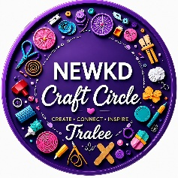
Connected Through Creativity
At NEWKD Craft Circle Tralee group, we celebrate the beauty of community through creativity, friendships, learning, and shared experiences.
Our installation for the Crafting Connections exhibition, Connected Through Creativity, features a giant ball of colourful wool, created as a symbol of the many unique people who make up our community group. Each person brings their own story, talents, experiences, ideas, and personality, yet we are all connected through friendships, support, conversations, laughter, learning, and the simple joy of creating together.
At the centre of the installation is the heart of our group - ball of wool with knitting needles, sitting on a map of Kerry. We started to weave the strand of wool from crocheted heart and shamrock. Together, they represent love, friendship, hope, Ireland, and the roots from which our community continues to grow. The colourful strands of wool flow and wrap around the giant ball. Each strand represents an individual person and their unique journey. Some strands take their own path, while others cross and intertwine, reflecting the different connections we make with one another.
Strands also carry the names of both current and past members, creating a lasting reminder that everyone who has been part of our Craft Circle has contributed something special to its story.
Two giant 36 mm knitting needles, engraved with the NEWKD Craft Circle logo, form an important part of the installation. They represent the tradition of craft and the power of making things by hand. Craft is not simply about creating an object — it creates opportunities to talk, share, teach, learn, laugh, connect, and build friendships.
The entire installation rests upon the golden map of County Kerry, reflecting how the friendships and connections created within our group extend beyond the NEWKD Craft Circle itself and continue to spread throughout our beautiful county.
The choice of 36 mm knitting needles also carries a symbolic meaning. In numerology, 3 is associated with creativity, joy, communication, and self-expression, while 6 represents caring, family, service, harmony, and community. Together, 3 and 6 create 9, a number often associated with completion, compassion, generosity, and humanitarianism.
In this artwork, these all meanings this group project beautifully reflects what NEWKD Craft Circle represents: creativity bringing people together, friendship creating a sense of belonging, and individuals coming together to create something greater than themselves.
Made by the community, for the community and this artwork has truly been a community creation.
It was made in collaboration with the members of NEWKD Craft Circle Tralee and local woodcarver Edgars Sasko. Every group member was invited to contribute a personal piece of thread, making the artwork not only something we created together, but something that contains a small part of each of us.
Every piece of wool, every name, and every connection has been added with a huge sense of pride, joy, friendship, and belonging.
Most importantly, this artwork reminds us that one person does not create a community.
It is created by all of us.
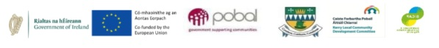
Like individual strands of wool, we may each be different and follow our own paths. But when we come together, we can create something colourful, strong, warm, and beautiful.

