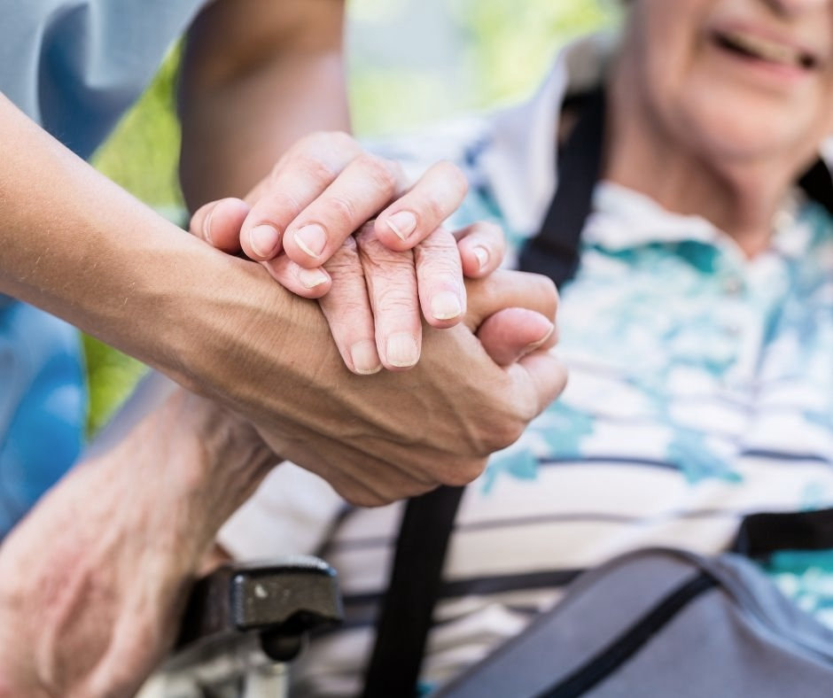**RECONNECTING WITH SERVICES DAY 2025**

**Event Theme: *Falls Management and Personal Safety***

**Thursday 9th October, 2025**

**Listowel Arms Hotel**

**10.00am—2.00pm**

**Speakers include:**

**Adult Safeguarding – HSE**

**Crime Prevention Officer - An Garda Siochana**

**Fire Safety & Fire Alarms - Local Fire Service**

**Avoiding Falls & Falls Management - HSE OT and Physio**

**Chair Exercises - Better Balance Better Bones**

**Over 25 Information Stands will be present.**

**An Garda Siochana, Community Healthcare Network 1,**

**NEWKD Home Maintenance Service, Senior Alarm Scheme, Home**

**Visitation, ReVamp, St. Vincent De Paul, Fame, Ard Churam, Age**

**Friendly Kerry, ICPOP, BBBB, Neurofunctional Zone, Local Link Kerry, and many more…**

**Tea/Coffee and Scones Will be Provided**

Booking is essential (No Walk-in)

***PLEASE BOOK BEFORE MONDAY 6th OCTOBER***

For further information and registration contact Ed O’Connor

E: edoconnor@newkd.ie / P: 087-7794765