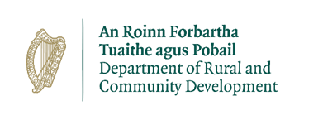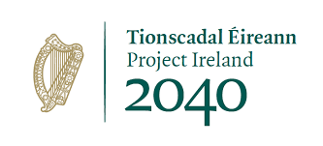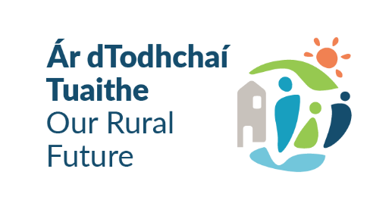

**Outdoor Recreation Infrastructure Scheme 2024 & 2025**

**NEWKD - Call for Expressions of Interest – Project Development Measure**

The Outdoor Recreation Infrastructure Scheme (ORIS) supports the development of new outdoor recreational infrastructure and the necessary repair, enhancement or promotion of existing outdoor recreation infrastructure in countryside areas across Ireland. The Scheme is funded under “Our Rural Future” which specifically prioritises the growing outdoor activity tourism sector as part of a long-term vision for a vibrant and sustainable rural Ireland.

Launched in November 2022, Embracing Ireland's Outdoors, Ireland’s Outdoors, the National Outdoor Recreation Strategy 2023 - 2027 is shaping the strategic direction of outdoor recreation in Ireland. The strategy will lead, guide and facilitate the sustainable development and management of outdoor recreation in the medium term. It is essential that all projects applied for under ORIS are consistent with Embracing Ireland’s Outdoors.

The Scheme is now delivered under four Measures. NEWKD is eligible to submit 1 application for funding to the Dept. of Rural & Community Development under the project development measure of the scheme which is outlined below.

**Measure 1: : Project Development Measure -** Development Costs for Strategic Large Scale Projects

**Max Grant Amount: €50,000. Max Grant Rate 90%**

Eligible Activities: This Measure will provide funding for the detailed development of projects which would enable them to reach a standard for application under Measure 2 or 3 of ORIS. Such work might encompass detailed design, preparation for planning and/or procurement, appropriate assessment, ecological surveys etc.

The overall aim for the investment under this Measure should be for the development of projects that are of a scale that may be funded under a future Measure 2 or Measure 3 application, or developed in two phases under such Measures i.e. projects with an expected delivery cost of less than €1 million (that are in line with the objectives and focus of this Scheme).

The approval of an application under this Project Development Measure does not guarantee approval of funding for the subsequent delivery of the project. All project applications are subject to a competitive application process under future calls, regardless of any previous funding provided.

NEWKD wishes to work with communities to identify projects under this project development measure.

NEWKD are therefore inviting expressions of interest from community groups interested in securing funding under the project development Measure of ORIS 2024/25. Applications will be submitted by NEWKD on behalf of the projects selected.

All projects must be finished and drawdown of funding completed with 18 months of approval.

Groups selected to submit an application or forming part of a multifund application will need to provide 10% match funding for their total project costs. Other state funding cannot be used to meet the 10% match funding requirement.

Full Details of the ORIS scheme can be found at the following [here](https://www.gov.ie/en/service/d14e1-outdoor-recreation-infrastructure-scheme/?referrer=https://www.gov.ie/en/collection/181e2-outdoor-recreation-infrastructure-scheme/).

Where more expressions of interest are submitted by groups than the available 1 application available to NEWKD-NEWKD will apply the following assessment considerations in selecting the applications to be submitted to the Dept. of Rural & Community Development.

Does the project meet an objective of Embracing Ireland’s Outdoors?

Does the proposed project address an identified need?

Would the proposed end project be eligible under Measures 2 or 3?

Is the project collaborative in nature?

If your group wish to be considered for funding – please complete the Expression of Interest Form and submit to the Rural Recreation Officer of NEWKD Joanna Jankowska by email or by post. Email & Postal details are set out in the Expression of Interest Form.

Closing date for completed Expressions of Interest forms is Friday 31st January at 5pm.

Late Expressions of Interest Forms will not be accepted. Any queries on the above – Groups should contact the NEWKD Rural Recreation Officer – Joanna Jankowska on 087 0562231 or by email: [joannajankowska@newkd.ie](mailto:joannajankowska@newkd.ie)