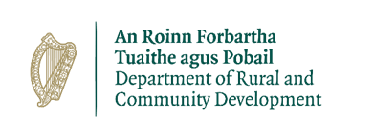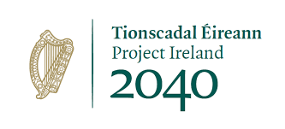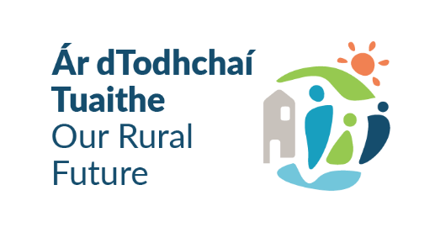

**Outdoor Recreation Infrastructure Scheme 2024 & 2025**

**NEWKD - Call for Expressions of Interest – Measure 1**

The Outdoor Recreation Infrastructure Scheme (ORIS) supports the development of new outdoor recreational infrastructure and the necessary repair, enhancement or promotion of existing outdoor recreation infrastructure in countryside areas across Ireland. The Scheme is funded under “Our Rural Future” which specifically prioritises the growing outdoor activity tourism sector as part of a long-term vision for a vibrant and sustainable rural Ireland.

Launched in November 2022, Embracing Ireland's Outdoors, Ireland’s Outdoors, the National Outdoor Recreation Strategy 2023 - 2027 is shaping the strategic direction of outdoor recreation in Ireland. The strategy will lead, guide and facilitate the sustainable development and management of outdoor recreation in the medium term. It is essential that all projects applied for under ORIS are consistent with Embracing Ireland’s Outdoors.

The Scheme is now delivered under four Measures. NEWKD is eligible to submit 3 applications for funding to the Dept. of Rural & Community Development under measure 1 of the scheme which is outlined below.

**Measure 1: Small Scale Repair/Development/Promotion and Marketing**

**Max Grant Amount: €40,000. Max Grant Rate 90%**

Eligible Activities: Small scale projects that are in line with the objectives and focus of the Scheme. This includes, but is not limited to, the upkeep, repair, maintenance and development of trails, walkways, mountain access routes, cycleways, blueways recreational facilities at bogs, rivers, lakes and beaches, natural play areas that form part of a larger outdoor recreation project and the promotion and marketing of such infrastructure. Projects should, where possible, indicate how they are inclusive of people with disabilities and older adults.

NEWKD wishes to work with communities to identify projects that enhance or redevelop existing amenities, or support new opportunities to develop local natural resources.

NEWKD are therefore inviting expressions of interest from community groups interested in securing funding under Measure 1 of ORIS 2024/25 for the upkeep/repair/development of trails/walkways/outdoor recreational facilities managed by them. Applications will be submitted by NEWKD on behalf of the projects selected. All projects must be finished and drawdown of funding completed with 18 months of approval.

Groups selected to submit an application or forming part of a multifund application will need to provide 10% match funding for their total project costs. Other state funding cannot be used to meet the 10% match funding requirement.

Full Details of the ORIS scheme can be found at the following [here](https://www.gov.ie/en/service/d14e1-outdoor-recreation-infrastructure-scheme/?referrer=https://www.gov.ie/en/collection/181e2-outdoor-recreation-infrastructure-scheme/).

Where more expressions of interest are submitted by groups than the available 3 applications available to NEWKD – NEWKD will apply the following assessment considerations in selecting the applications to be submitted to the Dept. of Rural & Community Development.

Does the project meet an objective of Embracing Ireland’s Outdoors?

Does the project clearly support outdoor recreation?

Does the proposed project address an identified need?

Are the timelines clearly set out in the application and realistically achievable?

Are there clear and reasonable costings for the project?

Are all the necessary permissions and screening in place?

Does the project align with the Climate Action Plan and is it project environmentally sustainable/does it include a biodiversity element? I

s the project collaborative in nature?

Does the project support an inclusive approach for people with disabilities or does it enhance the opportunities for people with disabilities?

Does the project outcomes have clear positive health impacts or benefits for local communities?

If your group wish to be considered for funding – please complete the Expression of Interest Form and submit to the Rural Recreation Officer of NEWKD Joanna Jankowska by email or by post. Email & Postal details are set out in the Expression of Interest Form.

Closing date for completed Expressions of Interest forms is Friday 31st January at 5pm.

Late Expressions of Interest Forms will not be accepted. Any queries on the above – Groups should contact the NEWKD Rural Recreation Officer – Joanna Jankowska on 087 0562231 or by email: [joannajankowska@newkd.ie](mailto:joannajankowska@newkd.ie)