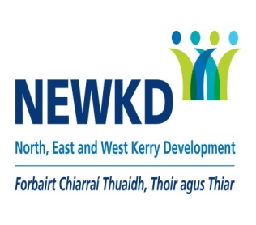

**Kerry Local Area Employment Service**

is recruiting for the following vacancy:

**EMPLOYMENT OFFICER**

**3 Days per week, based in NEWKD Office, Castleisland.**

**21 Hours – 9:00am-5:00pm.**

**(Fixed Term Contract ending in October 2025)**

**Salary Scale between €28,438 and €47,717 per annum.**

The successful candidate should possess the following:

| * 3 years’ experience working in the area of unemployment, employment, enterprise and/or career guidance * Experience working with barriers to employment. |
| --- |
| * Good Computer Skills, experience of a CMS system an advantage * A formal qualification or study in the area of guidance or counselling or other relevant area Qualified to Level 7 and/or be willing to work towards a Level 7 accreditation |

**To apply, please email CV and Covering letter to** [**jobapplication@newkd.ie**](mailto:jobapplication@newkd.ie)

**Closing date for receipt of applications is Sunday 23rd July 2023.**

NEWKD is an equal opportunities Employer

