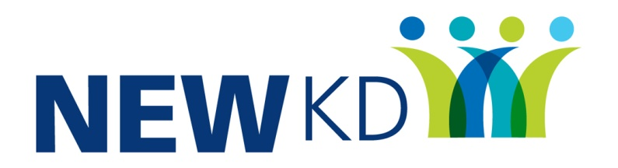

Community Development Worker to support Ukrainian Refugees

North East & West Kerry Development is a local development operating across the North East and West Kerry including Tralee, Castleisland, Listowel and Dingle. We deliver a range of programmes that aim to improve the quality of life for all the people within our community.
The company are recruiting for a Development Worker Position under The Social Inclusion and Community Activation Programme (SICAP). SICAP provides funding to tackle poverty and social exclusion at a local level through local engagement and partnerships between disadvantaged individuals, community organisations and public sector agencies.
SICAP is part of the community response supporting Ukrainian refugees and we wish to recruit a suitable person to further support this work.
The focus of this position will be to support Ukrainian Refugees in the NEWKD area.
Key elements of the work will include, working directly with Ukrainians to assess their needs, supporting them to integrate and settle into the community, providing relevant information as required on rights, entitlements and responsibilities.
Key requirements
- Third Level Qualification
- Experience of working in the community /social or relevant sector with transferable skills
- Fluent Ukrainian and English
- Strong Interpersonal Skills
- Driving License

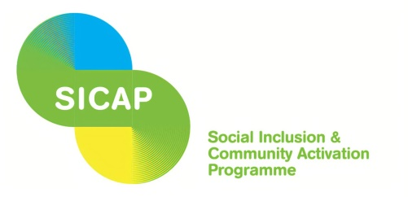

Job Description
1. Local Development Organisation Name: North & East Kerry Development.
2. Job Title: Ukrainian Development Support Worker
3. Reporting to: Social Inclusion Programme Manager
4. Salary and Benefits: Development worker scale the actual point will depend on experience
5. Job Purpose: To support Ukrainian refugees who are resident in the area in whether in group or residential accommodation. To be link person on the ground where required and / or a support person working with other agencies to ensure that the refugees are receiving the required supports.
6. Base: Primarily Dingle but may have to work in other offices also – NEWKD has offices in Tralee, Listowel, Castleisland, and Dingle and base may change based on work demands

7. Contract: Fixed Term Contract for a period up to end-2023. Flexible working hours including some evening & weekend hours

8. Duties and Responsibilities:
Project Initiation and Implementation as per Work Programme
- To link with refugees as required, assess needs, listen to issues and respond effectively in a timely manner
- To have an understanding of the rights, entitlements and responsibilities of the refugees and communicate these clearly and accurately
- Building & maintaining links with key agencies
- To ensure confidentiality as regards personal information and ensure that the support work and related information is GDPR compliant
- To conduct the work with an awareness and sensitivity around cross cultural issues

Budget management and project administration
- To manage budgets for your actions areas as required
- To maintain accurate files for all funded initiatives as per directed by SICAP guidelines and in line with administration procedures in NEWKD.
- To adhere to relevant deadlines and reporting mechanisms for budgetary expenditure.

Office & Reporting Systems
- To input into the IRIS system as required
- To produce written reports as required
- To follow all general work administration procedures and policies.
- To produce publicity materials as required

General Requirements (for all Staff paid by North and East Kerry Development)
- Participate in effective teamwork
- Work flexibly including occasional evenings
- Undertake such personnel training as may be required to keep up to date and fulfill the professional requirements as identified in this job description.
- At all times to adhere to the policies and procedures NEWKD.
- Carry out any other reasonable duties as requested/necessary

9. Skills
- Good writing skills to develop reports, promotional materials etc.
- Ability to plan, organise work and understand planning methodologies
- Good ICT skills such as Word, Canva or similar, digital survey packages, and ability to use digital technologies such as Zoom, Microsoft Teams.

