
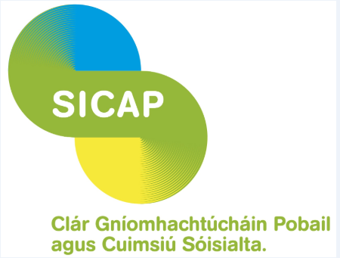

Basic Accounting for New Small Businesses

Free Course

Venue: Áras an Phobail, Croílár na Mistéalach, Tralee, Co. Kerry, V92 CRW8

Time & Date: Wednesday 12th October, 2022
10 am to 12 noon

Trainer: Antoinette Glavin - Glavinwiseman.ie

Overview
This course gives an overview to how to set up your accounting system for a business.
It covers:
- Legal Status of Business
- Set up
- Statutory Registration
- Tax Registration
- Tax Filing Deadlines & Tax Payments
- PAYE & VAT
- Setting up a bank account
- Accounting & Tax term
- Record Keeping
- Expenses
- Cash-flow
- Why hire an accountant
- Revenue Commissioners
- Case Study
- Tax Clearance
Who is this course suitable for?
This course is for someone who is on a social protection payment but wishes to explore the idea of starting their own business, someone on work scheme, or previous BTWEA clients of NEWKD.
This is a 2 hour LIVE online course which you can attend from your home or office using a PC / MAC or tablet (you will need to be able to hear sound either through speakers or headphones but you do not need a webcam). Please note that the larger the screen you use the better the experience will be.

How does it work?
Click on this link to watch a video which explains how the online course works
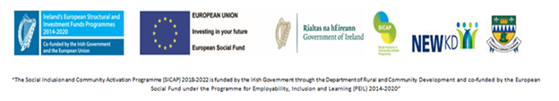
https://www.youtube.com/watch?v=-22oijicLM4

