NEWKD wishes to recruit a Community Employment Supervisor for the TEAM Project - CE Rehabilitation Outreach Scheme. This scheme is funded by the Department of Employment Affairs and Social Protection.

Primary objectives of the scheme
- To provide persons in recovery from substance misuse issues with meaningful, tailored and flexible training and education opportunities
- To facilitate their progression to further education and training options and/or labour market participation
- To assist participants to work towards economic independence and to be fully integrated within the community

The Role
The role of the CE Supervisor, under the direction of NEWKD, as the CE Sponsoring Organisation, is to support recovering drug rehabilitation participants to develop their personal, social and work related skills to enable them to participate fully in community and working life. Duties to include: Preparing financial returns, wages, wages claims, material and participant claims and bank reconciliation forms. Completing administration duties such as recording and inputting data, cheque payments books, filing etc.

Person Specification
- Work Experience
- Previous supervisory and people management experience relevant to the post
- Previous experience in Administration, Project Management and/or Training or other relevant positions; and
- Experience of addiction issues and working with service users towards rehabilitation.

- Interpersonal Skills
- Effective communication skills;
- Competent report writing skills;
- Experience of working with vulnerable individuals and job-seekers;
- Capable of directing, motivating, coaching and mentoring CE scheme participants
- Ability to work with other addiction support services;
- Ability to work as part of a team;
- Ability to work under the direction of the Sponsoring Organisation for the effective implementation of the CE Programme in line with all areas of the CE Procedures Manual.

- Qualifications
- Major Award at 3rd Level (QQI Level 6 or higher) in Business / Financial Administration, Training ,Addiction studies , Human Resources, Project Management, Social Studies, Community Development or a related discipline;
- ICT skills essential (e.g. MS Office).
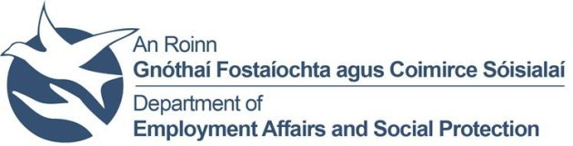
Apply by sending CV and cover letter, clearly stating the role you are applying for to jobapplication@newkd.ie.
Shortlisting may apply. Full driver’s licence and access to own transport required. Garda vetting will apply. A panel may be formed.
Closing date for receipt of applications is 5pm on Friday, 12th August 2022
NEWKD is an equal opportunities employer. Canvassing will disqualify.

