North East West Kerry Development



**NEWKD SICAP Case study 2020**

*Delivering SICAP supports to communities during Covid*

**Overview**

On March 27th as a result of the increasing number of Covid19 cases Ireland was placed on almost full lockdown with a range of restrictions including no non-essential travel outside of a 2km radius and it was also recommended that those aged 70 and over confine themselves to their homes.

Like many other workers the SICAP staff were under lockdown and were working from home. The delivery of SICAP is people intensive and involves relationship building with individuals, groups and communities, often meeting people where there are located (e.g. in the local estate or community hall).

*Given these circumstances, in the SICAP team we asked ourselves 2 initial questions:*

**What is the best way we can use SICAP resources in order to provide support to people right away?**

As it was obvious that that these restrictions would be challenging for communities and vulnerable groups in particular, NEWKD decided to develop its own ***Community Response Service*** based on requests and needs in the area. This was ultimately linked with the interagency Kerry County Council lead Countywide Helpline from which we would receive referrals. It was decided that SICAP would lead out this response by providing both funding and staff. SICAP staff are strongly networked into various communities, have good interpersonal and problem solving skills and therefore were a good fit for this work.

However SICAP still had a full SICAP plan to deliver and therefore the second question was:

**How do we deliver a people centred programme to target groups when we are not allowed to be near people?**

We approached this as follows:

1. Contacted clients initially by phone and email and then via Zoom, to touch base and find out their most pressing needs
2. Looked at differential needs (i.e. Lone parents, those in direct provision, people on low income
3. Try to provide practical supports to those who need it most
4. Developed a revised ***adapted plan***
5. Under the adapted plan the company quickly transferred supports online using zoom for group and individual meetings and developed a programme of online training across different actions

|  |
| --- |
| **Case Study** **Purpose** |
| This case study shows the flexibility, innovation and responsiveness of SICAP to the needs of target groups and communities during the Covid Crises through the development of a *Community Response Service* and a *SICAP Adapted plan*. This is illustrated using 3 examples   * **The Community Response Service** * **Laptop loan scheme** * **Supporting Social Enterprises to reopen after lockdown**. |

**Example 1 NEWKD Community Response Service**

**The issue:** The over 70s, people with underlying conditions, Lone parent households and those living in poverty. These were example of groups who were vulnerable to becoming marginalized during the lockdown, some of whom required supports. NEWKD started to work on a **Community Response Service** shortly after lockdown and it commenced operation in April. SICAP staff led out this response and SICAP was the primary programme involved in its implementation.

**The Service**

Key steps which were undertaken in developing the NEWKD community response included:

**Databases:** SICAP remained in contact with our clients – NEWKD had databases of our existing clients through our work programmes – they were contacted to establish who required our help and support. **Other Databases were** developed or updated as follows -

A. Database of the local community groups – Name of group, contact person, phone, email

B. Database of NEWKD staff supports – deliveries, manning phones, etc.

C. Database of local shops, chemists, fuel suppliers, butchers etc.

**The scope of the service delivery**. Teams were developed in each office area to take calls both from NEWKD local numbers or referrals through the countywide helpline. Staff would undertake deliveries and act as a facilitator around general supports where possible.

When the Council announced a county wide response to be coordinated through a local response forum, NEWKDs response was integrated as part of this, including taking referrals through local area staff and also providing staff directly to answer calls on the central line. The following services were provided

* Get peoples shopping done and delivered
* Collect pensions
* Collect prescriptions
* Take rubbish to the dump
* Get small, necessary jobs done – grass cutting, gutters cleaned, power washing
* Bring their newspaper
* Organise regular ‘friendly calls’ by phone

**Protocols for delivery** – were developed to ensure the safety of staff and communities and phones were purchased for staff with new numbers

**Communication -**The service was launched first in Listowel to work through any issues. The service was then commenced throughout the area and promoted through all key media with the following service descriptor:

*NEWKD Supporting Communities, Families and Individuals in this Time of Need*

*Are you in need of a delivery service? NEWKD may be able to help!*

*Call any of the numbers below in your local area (between 9am & 5pm any day) and we’ll put you in contact with a local community group or person who can deliver to you.*

*Listowel: Dave 087 9379121 or Ann 087 8248180*

*Call us we would love to help !*

**Jim Client example –it’s not just about the meals**

Jim (not his real name) is an example of a client helped through the Listowel Family Resource Centre Meals on Wheels Service which was supported by SICAP.

Jim has lived all his life in Listowel and is now retired. He is very active in the community has sat on the boards of various local committees, he is politically active, an ardent lover of card nights, particularly bridge and an active club member in his local GAA club. He has children who are living abroad.

When he retired he stayed active in the community. He told the SICAP development worker that “that his wife threw him out of the house every day because that was her workplace and she ‘never sat around his work when he was busy’. Last year his wife had a serious stroke and that he had become her full time carer. In more recent times that task had become too much for him so she was moved to the local nursing home where she got the care she needed and he was a daily visitor.

After Lockdown the Listowel Family Resource Centre had accepted an offer from a local chef who offered to cook dinners for clients that the FRC would have supported in the centre prior to the lockdown. These clients would have been children from low income families who would be in childcare or afterschool services and would have been fed in the centre on weekdays and older people availing of different supports within the centre. With schools, playschools and crèches shut and an imposed ‘cocooning’ on older people it was decided that a food delivery service would be offered.

**The Response**

Through SICAP NEWKD were in a position to support this through providing staff to deliver the meals, and SICAP funding to purchase food. Through connections with the Kerry Group SICAP staff also secured a number of food donations which helped greatly.

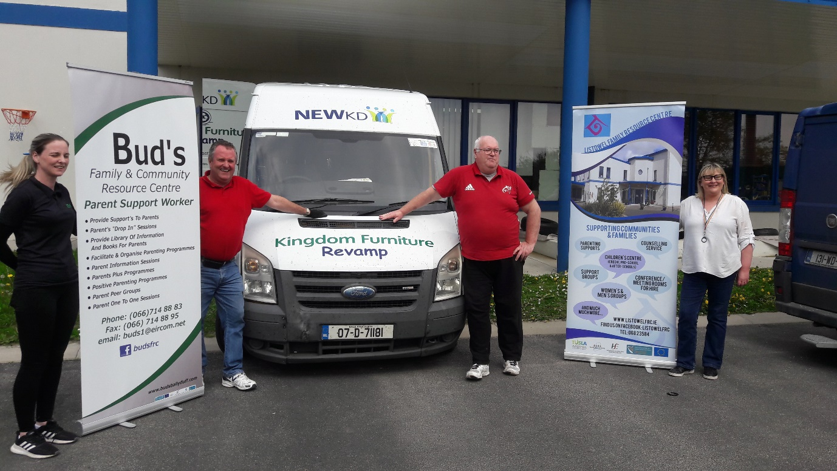

Collecting food from Kerry group which was distributed to Listowel and Buds FRCs

The meals delivery service took place, Monday, Wednesday and Friday each week. NEWKD collected the food from the FRC with each client’s dinners in individual bags clearly labelled with name, address, phone number and Eircode. Every delivery also became a social interaction. Short but important.

Jim, living alone and now is further isolated and affected by the fact that he can no longer visit his wife in the nearby nursing home. Her stroke, coupled with the onset of dementia, means that even phone calls are not possible and he is reliant on a quick update from staff each day regarding her condition as she becomes less well. A SICAP development worker who was one of those leading out the delivery service recounts “I am struck by the sameness of our brief chats during deliveries. ‘Still Cocooning’ he’ll start with a laugh, never much on the television, trying to keep active in the garden, really miss the local GAA club matches’. And the constant thank you, God bless, see you in a couple of days.

One Saturday I called to him. It was sunny and warm. I asked him to meet me at his back door and we sat in the garden for an hour. I was his only caller for the duration of the lockdown. His sons rang regularly but he said there was never any news. He told me that he disliked video calls because they made him realise how far away they were. He found the calls with his teenage grandchildren awkward and really missed to chit chat, said the video calls were too staged and felt unreal. He also told me he was ashamed of how he felt because others needed help a lot more than me, he was being well looked after. We met every Saturday and, bizarrely it never rained on any of the visits”

**Outcomes**

Supporting the meals on wheels was just *one action* as part of the **Community Response Service**. Below is the number of overall client interventions provided throughout the area across the various supports provided

|  |  |  |
| --- | --- | --- |
| **Area** | **Breakdown** | **Primary referral agents** |
| 1,282 Listowel | Meals on Wheels /Food Hampers  1,116  Shopping 99/Post Office 29 | FRC, NEWKD promotion, Supervalu.  Referrals in Listowel area from Community Helpline were minimal |
| 59 Tralee | 22 Groceries - Shop / Deliver  4 Waste  4 Grass Cutting,  11 other (technical, plumbing,  Other -18 | NEWKD Promotion, SVDP, Community Helpline. |
| 12 Castleisland | Information -2  Deliveries 10 | NEWKD promotion, Community Helpline. |
| 10 Dingle | Information 3  Deliveries 7 | NEWKD promotion, Community Helpline |

* The service reduced stress on vulnerable people knowing that they had support when required
* Enabled people to get essential services
* Provided food for people who couldn’t afford it (SICAP also supported the Foodshare service)
* Provided a social support

**Learning**

* Communication, a quick chat etc. with someone who is isolated as people were in lockdown is in some cases more important than the actual service itself
* The issue of food poverty requires more research. There was an increase in food donations required during lockdown but it is not clear if all this was due to food poverty
* Staff found doing this work very rewarding. Development work is complex and sometimes the staff member themselves don’t get to see the results in full directly
* The service couldn’t be rolled out immediately, it required organisation and linking with a variety of groups which took time, but this was necessary
* The response took a couple of weeks to organize. In the event of another lockdown type scenario, the service will be rolled out quicker as the systems are now in place due to the learning from this project

**SICAP contribution** -5 SICAP staff member’s time and approx. €3,000 in funding towards food

**Example 2 Laptop Loan Scheme**

**The Issue**

As all major activity migrated online during the lockdown, NEWKD was contacted by people asking where they could access a laptop as they or their children needed use of one for school or college work. Many families were under pressure to support students with their homework often in houses where there were a number of children and a lack of suitable areas and conditions for study. The lack of a digital device was adding to this stress and proving to be a barrier for some students.

A diverse range of marginalised groups presented as being digitally excluded and referrals came from a variety of sources which helped to ensure that the service targeted.

|  |  |
| --- | --- |
| **Target groups referred** | **Referral Sources** |
| Asylum seekers and refugees  Low income families with 3 or more school going children  Students with disabilities  Third level students had access to laptops in college but not at home | Education Welfare Officers  Teachers  Family Resource Centres  Individuals  Tralee IT Access office  NEWKD staff |

The issue of lockdown exacerbated existing inequalities in access to the digital world which is now integral to all aspects of society. This is reflected in the type of referrals received.

*“HI I am a teacher in X school in the NEWKD area. I am emailing you with regards a pupil in my class that has no access to laptop or any device as parents do not have an email or own a smart phone, that is why I said I would email and see if there is anything available that could be arranged to give to this little boy to help at this time”*

*“I am a family support worker with x Project. I have contacted you about the possibility of securing a laptop for an adolescent I am currently working with. The family are living in homeless accommodation, single mother with 6 children. They are currently experiencing hardship in the form of financial difficulties, shortage of food and lack of any technology for the children to access learning materials. They currently only have a TV, not connected, and can only play DVDs. “*

**SICAP Response**

Using SICAP funding NEWKD purchased a number of laptops, devised a service user agreement and started loaning out laptops. Unfortunately the demand outstripped the supply and therefore we approached Tralee Chamber of Commerce to see if we companies would like to donate to the scheme.

The chamber agreed and we advertised the scheme and over the next few weeks received a number of laptops which enabled us to loan them out across a number of different target groups with a variety of needs.

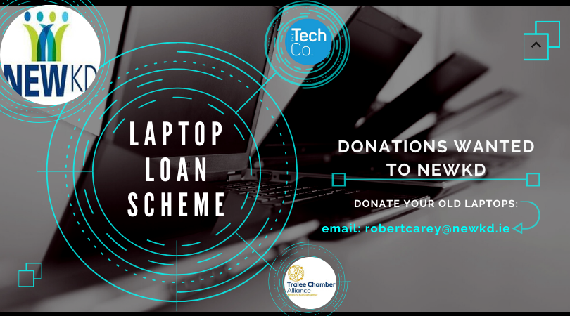

***Advertisement used on social media.***

Donated laptops had to be “cleaned” for GDPR purposes and in cases where there were upgrades needed these needed to be provided.

Chamber member “the Tech Company“ offered to do this work for free except for the cost of any new parts and this was of huge benefit.

The biggest challenge was that demand outstripped supply and we developed a waiting list.

**Outcomes**

* Overall 20 people were supported with Laptops over period April –June
* The scheme enabled children to undertake their schoolwork during lockdown
* The ability of students to engage in their school work helped to reduce one stressor in the family home when families where facing multiple challenges
* The scheme enabled third level students to complete assignments, some of whom would have had to re-sit otherwise
* Enabled 2 children with disabilities to keep contact with friends

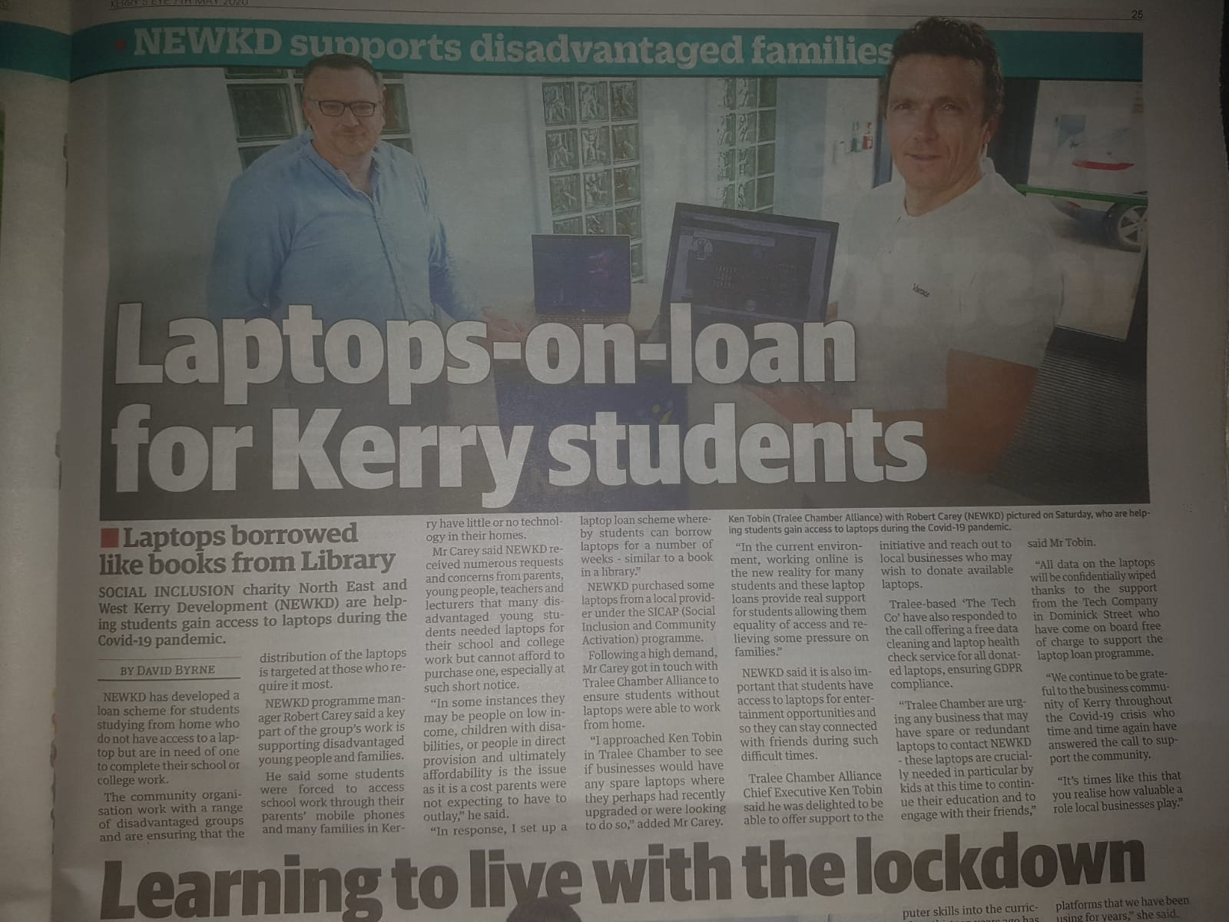

***Ken Tobin Tralee Chamber of Commerce and Carey NEWKD –Courtesy of Kerry’s Eye***

**Learning**

While the changes under Covid mean that for the foreseeable future a lot of education will now take place online, many families are digitally excluded. This may take the form of lack of laptops or tablets, lack of broadband access or in some cases there was no smart phones in the house.

While all donations were welcome, there should be potential to get more donations from business and we will have to analyse how best to do this.

The Laptop loan agreement needs to be tweaked in order to gather better information regarding the client and their needs.

The barriers to learning the current environment which were there already have been exacerbated under the C19 restrictions. There are other barriers such as capacity of parents to support children in undertaking their homework, lack of appropriate setting (i.e. space, etc., and lack of ICT skills). NEWKD will link with other agencies to see how we can support some of the higher need students who are experiencing barriers

**SICAP contribution -**1 staff member’s time and €3500 approx. in funding for laptops

**Example 3: THE REOPENING Of SOCIAL ENTERPRISES IN LINE WITH COVID 19 RETURN TO WORK PROTOCOL**

**The ISSUE**

During the COVID 19 crisis, a lot of social enterprises previously supported by NEWKD SICAP closed their doors, or significantly reduced their service provision. As lockdown measures began to lift, the feedback we were receiving from social enterprises was that they would need support to open up services again.

**During the COVID 19 crisis, Social enterprise in Kerry fell into one of 2 categories:**

A large number of groups were forced to shut completely as the service they provided was not deemed essential during the crisis.  As a result these Social Enterprises had no footfall and subsequently had no traded income.

Alternatively, for the Social enterprises who were deemed essential (i.e. respite care, meals on wheels, food bank) experienced a surge in demand for their services within the community and were somewhat firefighting to keep up with this demand.

This lead to problems such as:

* Due to social distancing, staffing hours have to be staggered
* Increase in overheads such as diesel, food etc
* Difficulty to access PPE
* Difficulty to maintain contact with board and some board members who may be cocooning

**Once lockdown measures began to lift, it was clear that reopening in line with HSE COVID 19 protocol would present a number of challenges to groups.**

Financial hit:

For most Social Enterprises traded income was depleted or significantly reduced. The hit to traded income would be long term, as social distancing would reduce footfall into buildings, thus reducing income earning capacities. Alongside this, the added cost of reopening services safely was significant and in most situations involved the need for adaptations, signage, extra PPE, sanitisers etc.

Changing and uncertain operating landscapes:

COVID 19 brings uncertainty and guidance is continuously changing. This proved difficult for groups to keep on top of changing guidance and to plan around it.

The need for expertise:

Health & Safety is an area of expertise, as is the HSE COVID 19 Return to work protocol and guidance. Advice is available from HSE, HSA and NPHET, but it can be difficult to understand this and properly enforce it. Groups did not feel confident that they had the correct up to date information, or comprehension of this information to allow them re-open their doors safely

Responsibility for People’s Safety:

For all groups the health and safety of all stakeholders, staff, service users, volunteers and the community at large is too top of their priority. Groups needed reassurance, direction and advice to allow could open their doors to community safely. Maintaining safety was paramount and at the forefront of reopening.

**SICAP Response**

When the planned lifting of lockdown measures began, SICAP wanted to offer supports to Social Enterprises that would be practical and tangible to assist them through this transition of opening up services again.

Groups needed to inform workers about what they need to do to help prevent the spread of Covid-19 in the workplace and many groups needed to change working practices. This would needed to be done in line with HSE COVID 19 return to work protocol in conjunction with HSA & NEPHET guidance

**SICAP assistance was provided to Social Enterprises in 3 ways:**

1. **Training**

An online workshop in ‘Covid 19 Compliance Training’ was facilitated in which 10 groups attended

1. **Grant support**

Grant support was given to a social enterprise to assist group with capital expense of reopening

1. **Completion of a Safety Review**

SICAP facilitated and funded the completely of 11 safety reviews by a qualified person and the subsequent provision of relevant health & safety documentation in line with COVID 19 protocol & Guidance

Each groups received a Site visit to review service, premises and procedures. All site visits were followed up with Covid19 packs / and Safety Statement to be added to each groups Safety statements. Follow up consultation, advice and guidance was offered individually to work through the issues and challenges of reopening.

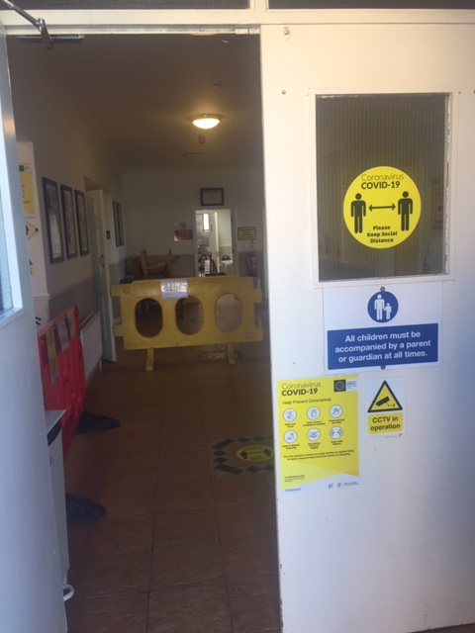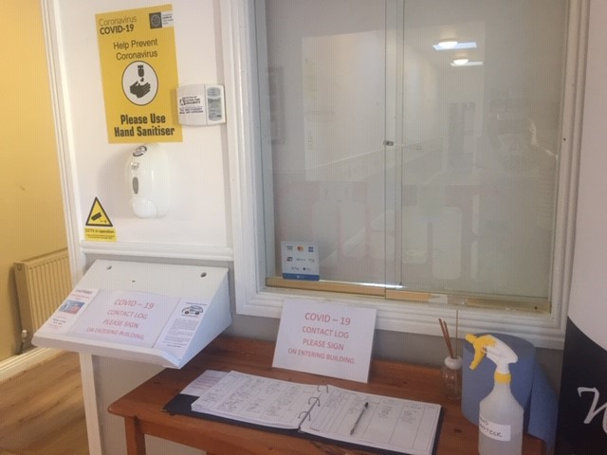

11 groups received a safety review in line with COVID 19 Return to Work Protocol**:**

1. Ballyheigue Community Centre
2. Listowel Community Centre
3. Kerry Respite Care
4. Lyre Community Centre
5. Knocknagoshel Gym
6. Knocknagoshel CC
7. Bud’s FRC
8. Rahonanne Community Centre
9. TIRC
10. Ballybunion men’s shed
11. Shanakill  FRC

**Outcomes of the SICAP Supports**

**Practical advice:**

A Site visit from a competent Health & Safety professional offered Social Enterprises all the necessary practical information and guidance to groups, on what was needed to open the doors safely and be compliant. This guided them to make the necessary adaptations in terms of signage, hand washing facilities, entries and exits. It also ensured that all correct paperwork, contract tracing, signing in policies etc was in place. The advice also offered guidance around best equipment to get (thermometers etc).

**Direction & guidance:**

Each group was given the most up to date information both through the online training and the direct site visits and also direction as to where to look in the future in order to remain informed as the Covid landscape is constantly changing. This also had the knock on effect where groups were able to direct community of best practices.

**Reassurance & Protection**

The site visit looked at existing policies, work practices and premises. The guidance over changes that need to be put in place gave reassurance to groups. Groups now had confidence and allowed them to concentration on resuming services and operations.

The correct advice and information protected the staff and community, but also protected the service itself from potential litigation issues going forward.

**Feedback from Groups**

**Knocknagoshel Gym**

*‘The site visit went well, got some practical advice appropriate for our set up’.*

**Knocknagoshel Community Centre**

*‘it went well, informative and it is a help to us in preparation for reopening’.*

**Listowel Community Centre**

*‘He gave good feedback and I found him very obliging in terms of answering questions and he’s made himself available for more after giving us the information today’.*

**Kerry Respite Care**

*‘Micheal was very reassuring and definitely helped with our approach to the Roadmap’*

**Ballyheigue Community Centre**

*‘We found Micheal to be very informative. I really needed an expert eye to give the Community Centre a once over to make sure we were compliant with the new Covid 19 protocols, and Michael gave some great advice and pointed us in the right direction.’*

**Buds FRC**

*‘Nora here from Bud's just giving up an update on Micheal Mathews of Safety Alliance visit to our centre also our Childcare Centre and Men's Shed here today.*

*He was excellent and very informative and covered every department. He spoke in plain concise language and said we could contact him any time we needed too. Thank you for giving us this opportunity. It has made us all feel a lot easier and he assured us we were on the appropriate guidelines. We would highly recommend him and would indeed work with him again’*

**Learning**

A lot of the supports we provide to Social Enterprises tend to be forward looking, e.g.: capacity building, planning, etc. However working with Social Enterprises during COVID 19, it was important to provide practical and immediate supports to help existing Social Enterprises get back on their feet.  It’s not always about developing new services; it is also about supporting the ones that are in operation now and struggling to survive.  COVID 19 and lockdown completely changed the landscape for social enterprises. Social Enterprises who were previously thriving are now struggling to open doors and have to completely change their daily operations.

Essentially there is little interest in long term planning, they can’t see past the next 6 months and keeping their doors open, and we have to change our support mix to reflect this and support this.

**SICAP contribution –** 1 SICAP Staff member time plusfunding as follows**:**

**Risk assessment** for 11 groups - €4,305.00

**Compliance training** in which 10 groups attended - €400

**Grant** for adaptions (321 Down Syndrome Kerry Shop) - €695.26

**Overall Conclusions from the Case Study**

Flexibility, Innovation & Responsiveness

In **example 1 – the Community Response Service –** SICAP lead out a new service which as not in the SICAP plan and which required supporting people dealing with unprecedented circumstances. The focus of this response primarily, though not exclusively involved older people for whom there was no specific action in our plan and therefore we effectively created a new action and target group and this involved reallocating resources, in terms of staff and money.

In **example 2 – Laptop loan scheme** – under an existing action whereby SICAP support those who educationally disadvantaged (A13) we responded to a barrier to education which had become more pronounced because of Covid 19 and we focused on the most excluded.

In **example 3 –Supporting Social Enterprises –** because of the close relationship built up with social enterprises through the provision of SICAP support, we were aware of their key challenges at that time and able to help them to respond to the key challenge of re-opening after lockdown.

Fidelity to the SICAP model

SICAP is not a programme which supports any person or any community, rather it targets its resources at specific individual and groups who are socially excluded. This approach is backed up by theoretical and evidence based frameworks from community development, equality and social inclusion. Therefore while being flexible it was important to focus supports on those who needed it most and we did this through looking at the impacts of Covid through an equality lens and looking at its differential impacts (e.g. on older people, people in poverty), and groups providing important local services and employment, often to target groups.

Connectivity

Engaging with people and developing relationships is central to community development work in general and SICAP in particular and this has been further illustrated during Covid. For clients like Jim who received the meals as part of the community response, having a chat to the SICAP worker was as important as the meal and for social enterprises dealing with uncertainly and stress NEWKD were in regular communication and also linking them up with other social enterprises and this engagement is appreciated. While more difficult in these times, NEWKD SICAP has managed to maintain connectivity through a mix of face to face and online supports.

Collaboration

Collaboration is a key principle of the model and was illustrated across these case studies through NEWKD SICAP working with community groups, other agencies and Chambers of Commerce and business, in order to support clients.