LDC Name: NEWKD
Lot Number. 19.1

Title: Kerry Mental Health and Wellbeing Fest, exploring SICAPs role in supporting community mental health and wellbeing.

Thematic Area –Collaboration
Target Group –People needing mental health and wellbeing supports in the community

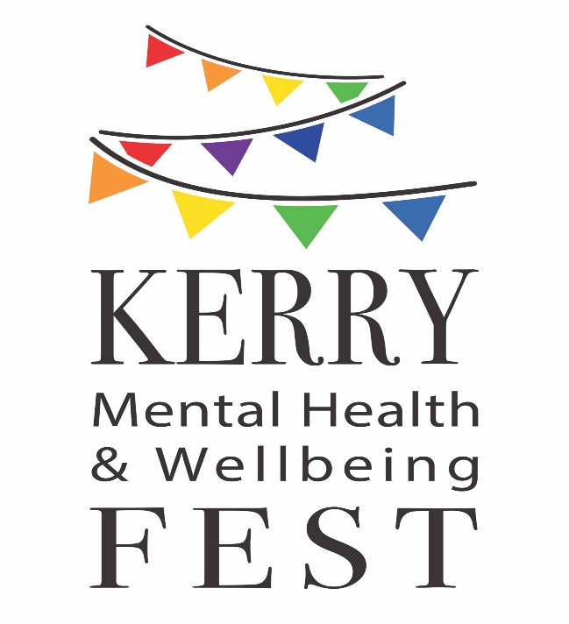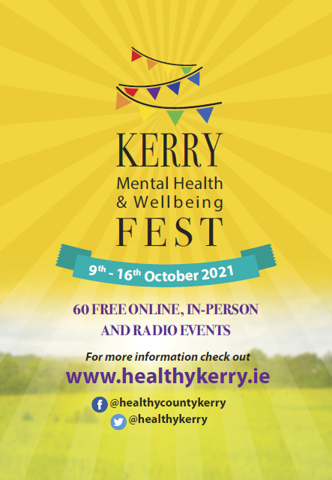
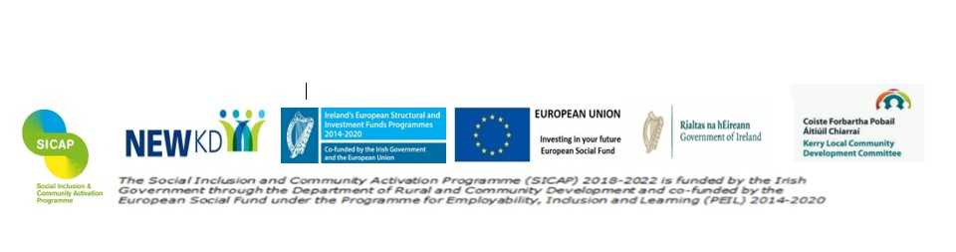
Overview
In the CSO Social Impact of COVID-19 Survey February 2021: it was found that almost six in ten respondents believe that the pandemic has negatively impacted on their mental health.
For many people the pandemic has exacerbated the symptoms of existing mental health conditions like anxiety, eating disorders, OCD, depression.
Conversely people with no preexisting mental health difficulties have been presenting to support services with anxiety, depression, loneliness and other mental health difficulties as the effects of the pandemic unfold.
Mental Health challenges In Kerry
In 2019, 312 residents of Kerry, 149 male and 163 female, presented to hospital with a total of 377 self-harm presentations. Taking into account the population, the rate of persons who presented to hospital following an act of self-harm was 204 and 218 per 100,000 for males and females respectively (NRSF report).
Self-harm includes; drug overdose, alcohol, poisoning, attempted hanging, attempted drowning and Self- cutting
Suicides
In 2019 there were 421 suicides recorded nationally. In Kerry, from 2017 to 2019 there was a rolling average of 12.4 suicides per year.

What can SICAP do to help improve the wellbeing of communities?
Some of the key ways to tackle the issue is to empower people through giving them access to information, knowledge, new life skills and the opportunity to try new ways to improve wellbeing. Through these activities we can tackle stigma through raising awareness of mental health issues and promote the idea that we all have mental health and we can do many things each day to help protect it and to build our resilience through ongoing learning.
As an organization that supports social inclusion, NEWKD acknowledge that good wellbeing is foundational to enabling people to participate fully and equitably in society. Therefore we provide a range of wellbeing supports for families, young people, adults, the elderly and even the micro enterprises which we support. We recognize that while mental health issues are in inherent in society, overall certain groups are more susceptible than others such as, people living in poverty, people, certain groups who suffer discrimination LGBT, or refugees for example.
Therefore SICAPs role is to support marginalised target groups in particular to access mental health and wellbeing supports across the key determinates and dimensions of wellbeing. This case study examines how a Mental Health and Wellbeing Festival in Kerry has contributed to these objectives and the role SICAP has in its annual success since 2018.

What is a Mental Health and wellbeing Fest?
It is a weeklong programme of events which aims to improve the mental health and wellbeing of the people in Kerry. It is organised by a multi-agency steering group made up of local agencies that support wellbeing in different ways. The Fest aims to raise awareness of the available supports and services in the county as well as to empower people to engage with the ‘Five Ways to Wellbeing’ through a dynamic and interactive programme of events.
The Five Ways to Wellbeing are:
- Connect
- Give
- Take Notice
- Keep Learning
- Be Active
The organising committee is a collaboration between Connecting for Life Kerry*, Healthy Kerry, Kerry County Council, the HSE, NEWKD, SKDP, Kerry Mental Health Association, Jigsaw Kerry, Munster Technological University/Kerry, and Kerry Volunteer Centre.
The ability of the committee member organisations to work collaboratively is one the Fest’s greatest assets as each member works to their strengths to bring an engaging programme of activities to the community each year.
*Connecting for Life is Ireland's national strategy to prevent suicide 2015-2020, and the work of the Fest compliments Goal 1, 3 and 4.
History of the Fest.
Kerry’s first Health and Wellbeing Week was held in October 2018. This project was collaboratively led by the HSE Cork Kerry Community Healthcare through Connecting for Life, and Kerry County Council through Healthy Kerry. A dedicated committee of local support services including NEWKD came together to plan a series of 49 events to celebrate World Mental Health Day here in Kerry.

Following the success of the 2018 festival, the interagency committee held a two week long Mental Health and Wellbeing Fest in 2019. Over 100 events were held across the county.

In 2020 the committee adjusted the programme to the constraints of the pandemic by holding most of the events online and some in person while adhering to all government guidelines and restrictions on numbers and social distancing. The programme of events for 2020 can be viewed here:
https://www.kerrycoco.ie/wp-content/uploads/2020/10/FinalKerryFest2020.pdf

The summary report for 2020 is available below and reports that 94% were 'more than satisfied' or 'very satisfied' with the fest 96% said they would attend a similar event again

https://www.healthykerry.ie/wp-content/uploads/2020/11/MHWB-Fest-Report-Final.pdf

What took place in 2021?
Programme of events for the week.
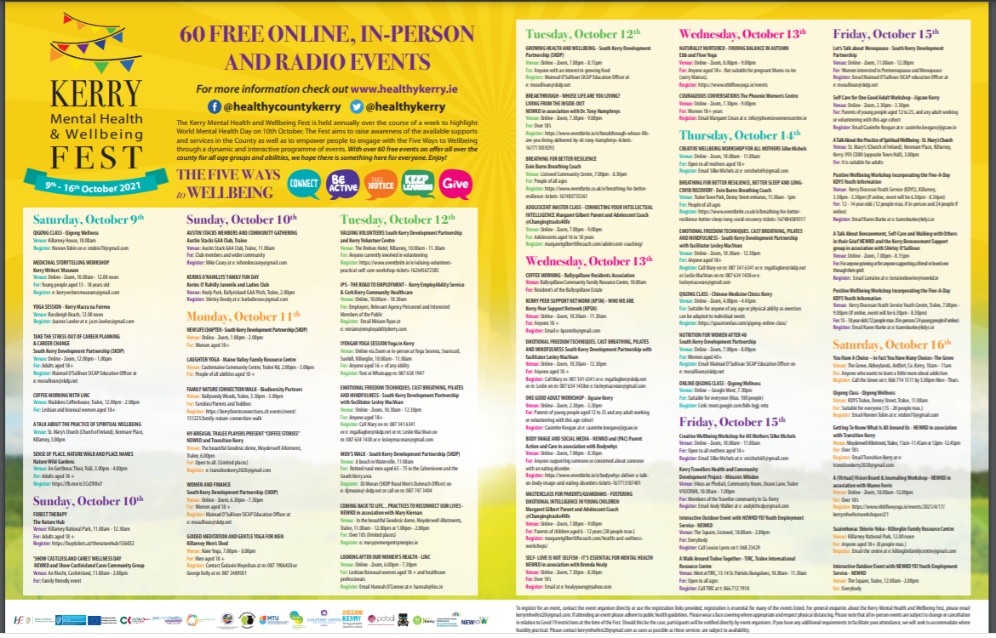
The full programme with further details of all events can be viewed here: https://www.helthykerry.ie/wp-content/uploads/2021/09/KerryWellfest-A5Brochure64673_WEB.pdf
An example of what you will see for each event:
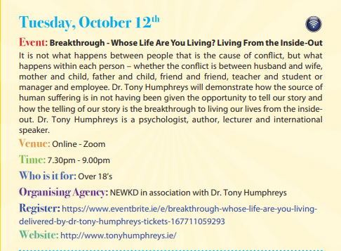
Fest presence on the airwaves
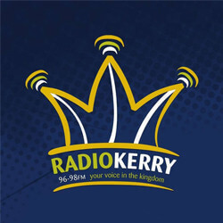

In addition to the 60 events held online and in person, the Fest committee teamed up with Radio Kerry to host a number of interviews with Fest facilitators to talk about their workshops and how they contribute to the Five Ways to Wellbeing. Committee members were also interviewed over the course of the week. Partnering with Radio Kerry allowed us to reach a wider audience by bringing the topic of mental health and wellbeing in to people’s homes, cars, workplaces etc.
Committee members also took part in the Just a Thought segment of Radio Kerry for the Fest. Each weekday morning one of the Five Ways to Wellbeing was highlighted.
Link to Ailish Brosnan, Senior Health promotion HSE and member of the Fest committee talks about the benefits of Taking Notice for our wellbeing.
https://www.dioceseofkerry.ie/.../10/5-Ailish-Brosnan.mp3
Link to Aislish Brosnan again on the importance of Keeping Active for our wellbeing
https://www.dioceseofkerry.ie/.../10/3-Ailish-Brosnan.mp3
Link to Sean Lyons, committee member on the importance to Keep Learning for our wellbeing
https://www.dioceseofkerry.ie/.../2021/10/4-Sean-Lyons.mp3
Link to Clo O'Keeffe Lyons, committee member from Munster Technological University, talks about the importance of Connecting with Others for our wellbeing
https://www.dioceseofkerry.ie/.../2021/10/2-Clo-Lyons.mp3
Link to Geraldine, committee member and Manager of Kerry Volunteer Centre, speaks about the importance of 'Giving' for our wellbeing
https://www.dioceseofkerry.ie/.../1-Geraldine-O-Sullivan.mp3

Photos from some of the Events.

The Nature Hub, Forest Therapy session at Ross Island, Killarney
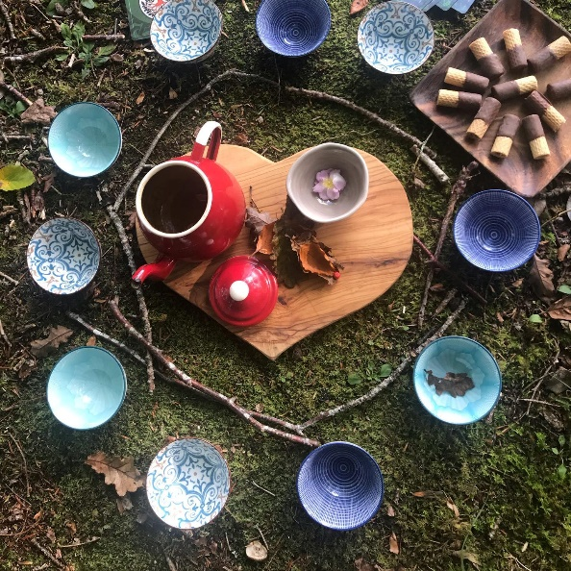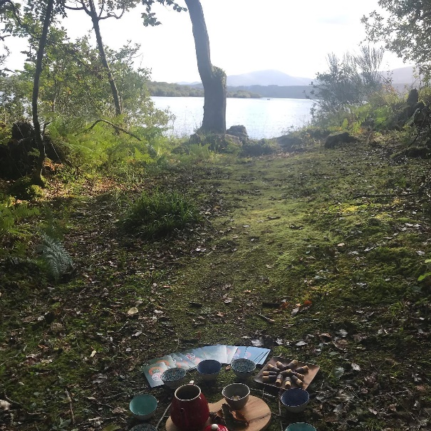
Follow this Link to hear Kerry Walker from The Nature Hub in a short video to promote her event and the Fest; https://www.facebook.com/watch/?v=584231982718493

Tralee International Centre, Walk around Tralee.
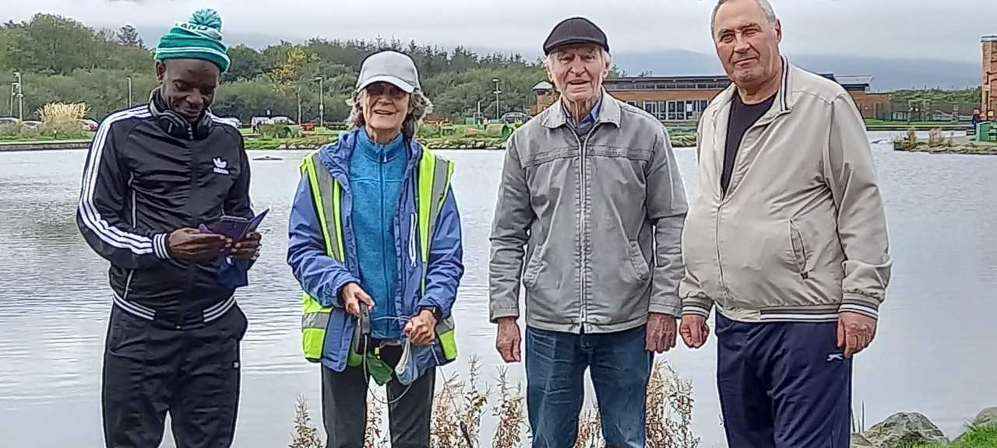
TIRC organised a walk to Tralee Bay Wetlands via Moyderwell Allotments where they were given a tour and also walked around the town park.

SICAP Contribution to the Fest.

NEWKD has a long history of including mental health and wellbeing as part of its community development approach. We have always incorporated mental health and wellbeing into our SICAP plan and it is currently the emerging need for the company. The SICAP officer like all members on the committee, advertise from May onwards through our contacts and social media platforms that we are looking for facilitators to take park in the FEST.
SICAP officers are in a unique position to contact and encourage the community groups we work with to take part in the Fest. Through our work in the community we can see emerging needs and respond by organising workshops relevant to the need, ideally in collaboration with the community groups we support. SICAP is responsible for organising and also funding a number of workshops during the Fest. The SICAP officer works with the printer and graphic designer to produce the Fest programme of events.

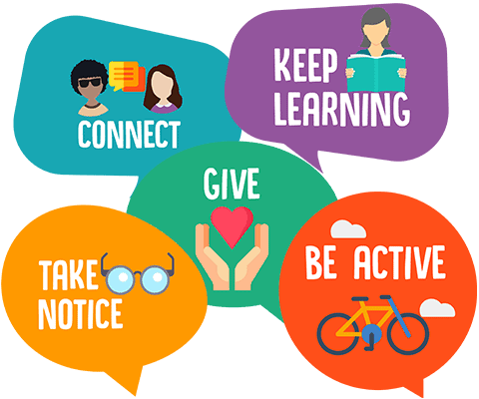

In 2021 SICAP organised and funded the following webinars, workshops and events for the Fest week: *the overall figures and evaluations for all Fest events are not yet complied
SICAP Event | Number of attendees
- Show Castleisland Cares Wellness Day, An Riocht, Castleisland. | 150 adults  195 children
- Bodywhys-Body Image and Social Media | 26 registered and 13 attended
- Tony Humpreys, Breakthrough-whose life are you living? | 113 registered and 65 attended
- Brenda Healy-Self Love is not selfish it’s essential for mental health | 26
- Shirely O Sullivan. Bereavement and Self-Care | 15
- NEWKD, YEI service hosted an interactive event in Listowel Town square | 10 (Covid numbers high in the town this weekend, very few out and about)
- NEWKD, YEI service hosted an interactive event at the Farmers market in Tralee | 40
- Hy-Breasal Drama Group Present "Coffee Stories" Three short stories set in a coffee shop by Frank Houlihan, local actor and playwright. | 25
- Mary Kiernan. Coming Back to Life... Practices to Reconnect Our Lives | 6
- Marike Dunk. Getting To Know What Is All Around Us. Open our eyes to the precious plants and habitats living within our urban spaces. Geodesic Dome, Moyderwell | 7
- Maeve Ferris. A (Virtual) Vision Board & Journaling Workshop. Uncovering the benefits of regular journaling & how it supports positive mental health & emotional wellbeing. | 29 registered and 19 attended
Total attended | 571

The role of ongoing SICAP development work in supporting the Mental Health Fest
SICAP provides ongoing supports in the area of mental health and wellbeing and this is manifest in many of the SICAP workshops which are organised in collaboration with the community groups NEWKD/SICAP has supported over the years to provide services to their particular area of mental health and wellbeing.
This support has helped to provide a foundation which makes it easier for a collaborative project such as the Kerry Mental health and Wellbeing Fest to develop and therefore it may be useful to view the SICAP role in the Fest through the longer lens of its role in the area of mental and wellbeing over a period of numerous programmes as well as its role in this particular event in order to get a clearer viewpoint.
Below is a sample of some of the groups involved in hosting the workshops and the role of SICAP development work in supporting these groups

Show Castleisland Cares community group Host a Wellness Day.
(A new SICAP community group)
In June 2021 a number of concerned individuals came to NEWKD interested to respond to the emerging mental health needs in their community. The SICAP YEI worker in Castleisland and SICAP development worker on the Fest Committee met with the group and subsequently asked the Suicide Resource Officer in HSE to attend a meeting with us. We spoke about the possibility of the group taking part in the Kerry Mental Health and Wellbeing Fest by organising a community information event which has been successful in other areas of the county.
The group agreed and NEWKD SICAP officers supported the group to choose a name (Show Castleisland Cares, create a logo, and plan the community information event for World Mental Health Day during the Fest.
The day successfully showcased over 30 supports and services available in the community for mental health and wellbeing and also had a strong family focus by providing entertainment for children on the day.
Throughout the day 150 adults signed in as well as 195 children. SICAP officers are now working on a community support booklet with the group and will continue to work together on new initiatives which will enhance wellbeing in Castleisland.

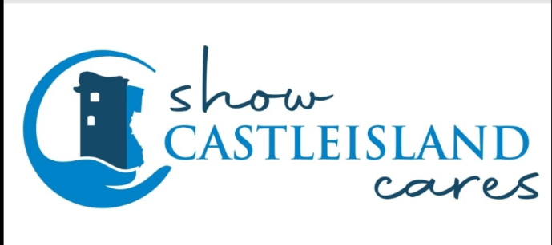
Show Castleisland Cares group logo.
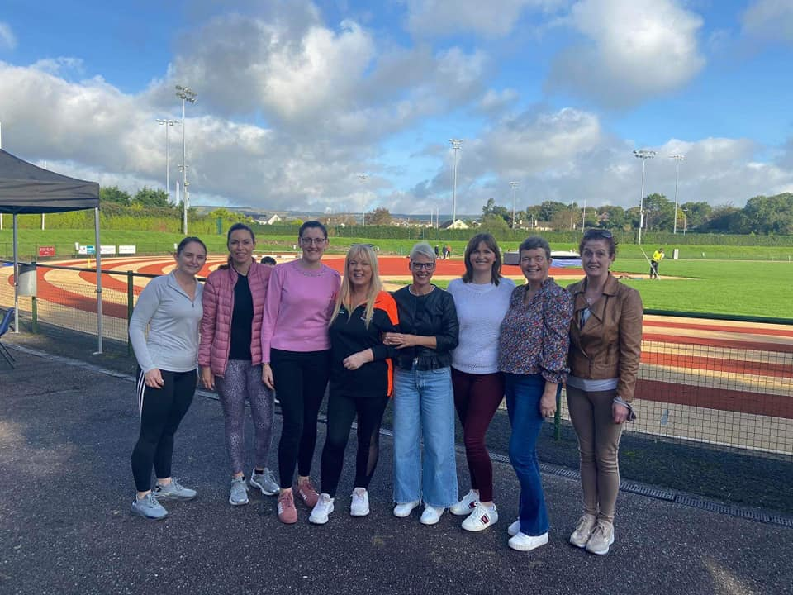
Show Castleisland Cares Committee
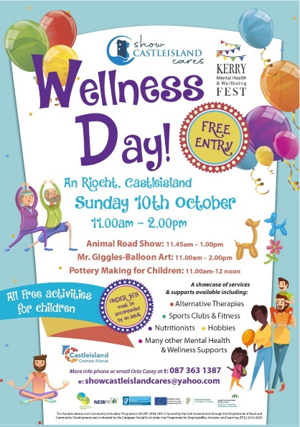
Testimonials from the day:
- “It had such a community feel good factor about the day. There was a great buzz of positivity thoroughly enjoyed it”
- “The social aspect and learning new information”
- “More knowledge of what’s available in the town for mental health”
- “Great to be at a social event where u can be around other people”
- “It was a fantastic event and well organised. It’s difficult to pick one part because the day as a whole worked really well. There was something for everyone from children to adults”

150 adults and 195 children attended.

Bodywhys-Body Image and Social Media Talk.
A talk on Eating Disorders and Supports.
A HSE briefing statement from 05/01/2021 highlighted the impact of the pandemic on children, including increased presentations of anxiety and anorexia nervosa. SICAP works with a local support group called PAC (Parent Action and Care) whose remit is to support anyone who is caring for a person with an Eating Disorder. Each year of the Fest, SICAP works with PAC and Bodywhys the national Eating Disorders Association of Ireland to present a workshop to the public on how to support a person with an Eating Disorder. This year we focused on Body Image and Social Media. The workshop is an opportunity for PAC to advertise their support group which now has over 60 people on their WhatsApp group (this has been their form of support to each other throughout the pandemic).

Online Talk about Body Image and Social Media
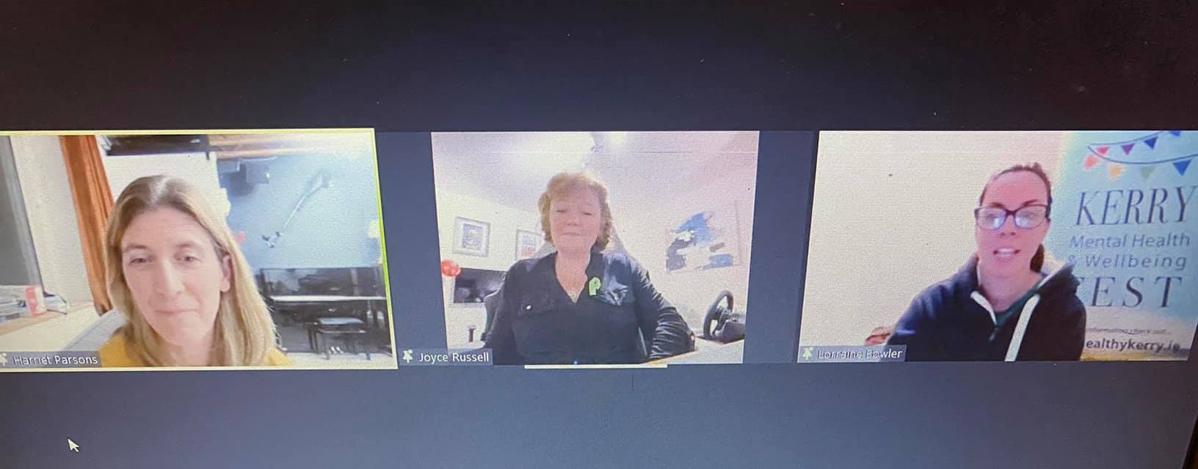
Harriet Parsons from Bodywhys the Eating Disorders Association of Ireland, Joyce Russel from local SICAP supported group PAC, a support group for those caring for someone with an Eating Disorder and SICAP officer NEWKD

Healthy Relationships workshops delivered by;
- Tony Humphreys, Breakthrough-Whose Life are you Living?
- Brenda Healy-Self Love is not Selfish it’s Essential for good Mental Health
Around 640 domestic incidents were reported to Kerry Gardaí in the first nine months of 2021.
SICAP support KPSN community group (Kerry Peer Support Network) and together are working with an interagency group to create an awareness campaign about coercive control in intimate relationships. It is from this work that NEWKD and KPSN spoke about including the theme of healthy relationships and especially the importance of relationship with Self in the Fest programme this year.
As a result the following webinar and workshop took place:
Tony Humphreys, Whose life are you Living? Tony demonstrated how the source of human suffering is in not having been given the opportunity to tell our story.
Brenda Healy, Self-love is not selfish it is essential for mental Health. The workshop provided tips and tools to nourish and build compassion for Self.
Feedback from the latter workshop has prompted us to offer a longer course in the New Year to individuals who attended and also the wider community in need of support in this area.

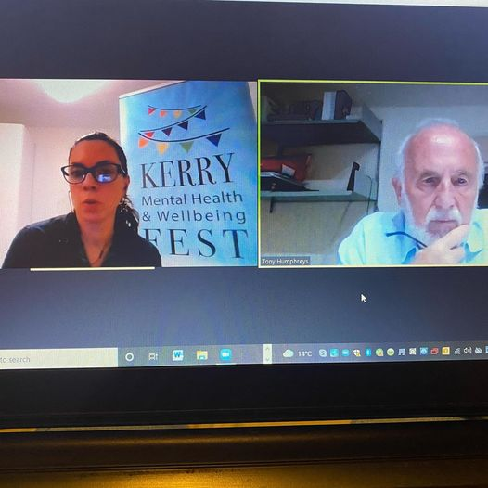
NEWKD and Dr. Tony Humpreys. Breakthrough, Whose life are you living?

Bereavement and Self Care workshop.
The Kerry Bereavement support group is a community group SICAP support and together we organised this talk for the Fest. (Delivered by Shirley O Sullivan)
The pandemic has been a difficult time for those who have been bereaved and newly bereaved. The Covid 19 restrictions have exacerbated the loneliness felt by those grieving for loved ones. We discussed the importance of self-care when you are supporting someone else on their journey through grief. The Kerry Bereavement Support group have subsequently held their first meeting since the pandemic began, in their new home- Rahoonane Community Centre, where they welcomed new members on the night who heard about the group at this talk during the Fest.

NEWKD YEI service, Interactive events in Listowel and Tralee town, Share the Vision
The SICAP Youth Employment Initiative workers invited people to come over and say ‘Hi’ and to share the vision of what keeps them well, using the Five Ways to Wellbeing as a prompt if needed. On the day there were some lovely natural conversations about what worked for them and how sometimes we forget to do the things that keep us well. This event and the Fest are good reminders to people to engage in the everyday activities that can help our wellbeing.
People shared their own stories of how they overcome their own challenges and how they maintain their wellness now. People also enjoyed having the chat with us in real life, given that COVID -19 has taken this away from us and made it more difficult to do. People who interacted also found out about the various services/supports available in the area and from NEWKD.
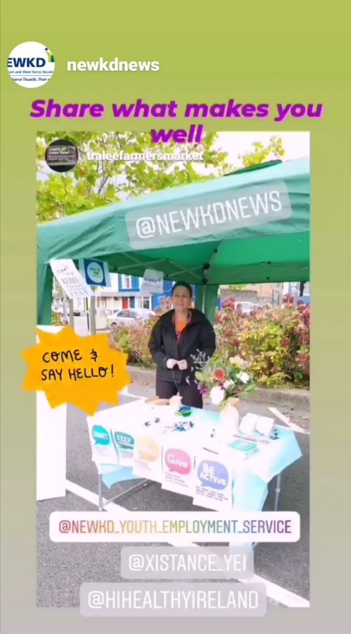
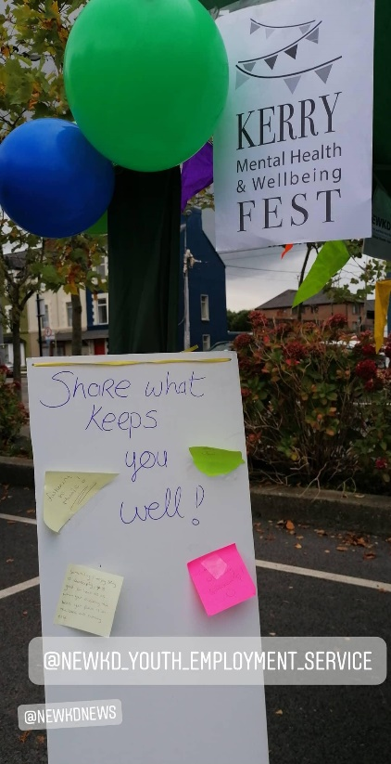

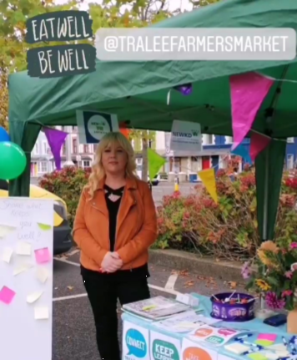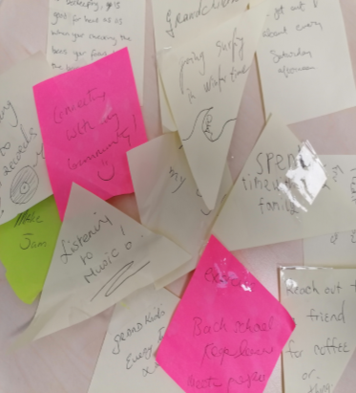

A sample of things shared on the day for our question; What keeps you well?
- Sea swimming
- Meditation
- Hiking
- Spending time with my family x 4
- Going out and about Saturdays
- Reach out to a friend for coffee and meet up
- Exercise
- Keep learning – went back to school
- Yoga
- Going for a drive
- Rest
- Gardening and growing x3
- Volunteering in my community – makes me feel good
- Meeting people
- Spending time with my grandchildren x 2
- Surfing especially in the winter time
- Bee keeping is good for my head – as when I’m checking the bees my focus is on the bees and nothing else!
- Drinking tea
- Going shopping
- Listening to old records
- Listening to music x 3
- Dancing in the kitchen
- Making Jam
- Hug/pet my dog x 2
- Connecting with my community
- Walking
Summary of SICAP resources

- SICAP development workers time on the committee from May to November 2021
- SICAP development workers time to work with the SICAP community groups to organise events for the Fest.
- SICAP development workers time and the SICAP YEI workers time undertaking development work with the new community group Show Castleisland Cares to host the Castleisland Wellness Day
- SICAP YEI workers time. 8 hours each over 2 events in the towns of Listowel and Tralee. Interactive events to promote the Five Ways to Wellbeing.
- No of individuals attending events directly funded by SICAP for the Fest: 571 individuals.
- The number of individuals on our NEWKD Facebook page is 3387 who would see info on the Fest and related podcasts and videos we share for the Fest week:
- SICAP Budget used €1842.90

Lessons learned

96.2 % of respondents to the Festival survey so far are female. (Note however that not all participants completed a survey). The higher number of female participation in mental health initiatives has been identified in NEWKD/SICAP as an issue for attention. In 2019 there were 421 deaths by suicide (317 Male and 104 Female) registered in 2019. This high male-to-female ratio is a constant feature of deaths by suicide over the years (NOSP briefing, 2021). There are serious gender equality issues as regards mental health outcomes and engaging men in the Five Ways of Wellbeing through the Fest could be one way to help tackle this and therefore it will be an important focus in 2022. Whilst attendance at events was recorded there is no breakdown by gender other than the breakdown by those who completed the survey, an appropriate recording mechanism will be looked at in 2022.
Young people were also poorly represented in terms of their participation at Fest events and this is something the committee will also address in 2022.
Whilst the Fest is advertised widely each year, we still hear about people being unaware of the events for the week, this is something we will address early in our planning for 2022 in terms of our modes of communication with the different age cohorts as well as a longer lead in period to advertise.
The committee are very proud of the Fest and aim to improve on delivery and content year on year. One of the actions for NEWKD on the committee next year will be to create a Tool Kit that other Local Development Companies, Family Resource Centres or Community Centres can use as a guide to start their own Mental Health and Wellbeing Fest for their county or town.
What happens next?
The Kerry Mental Health and Wellbeing Fest will continue in 2022, some events will take place online as feedback throughout the year in SICAP has been that is has provided those without transport or childcare the opportunity to attend events they would otherwise have missed out on. The majority of events we hope to hold in person as the pandemic has taken its toll on the unique benefits of in person social interaction. Further data and analysis on this year’s Fest is yet to be completed and our planning for next year will take into account the feedback. We look forward to delivering a bright and varied programme again next year.

Testimonials from participants from a wide range of online and in person Fest events.
- Noreen and Qigong were fantastic, and great introduction and start to the festival programme.
- Tony Humphries - excellent speaker. Great choice- thank you.
- Great variety, pity there’s not more in person
- Dr Tony Humphreys talk was brilliant, really enjoyed it!
- This is my first event attending it was really informative!
- Excellent and well organised
- Tony Humphries was most enlightening
- Very inclusive programme, very happy to know all Kerry has to offer. Impressive
- GREAT IDEA COVERS MANY AREAS YOUNG AND OLD WELL DONE POSITIVE MOVE
- Super to be able to connect from home and be enriched by talks and prompted to think and give time to me and my relationship with me
- The Show Castleisland cares event in person was so needed and very informative, fun day, great to connect with people and the community again.
- It was very informative. The practical, real life examples given tonight showed me how necessary it is to tell my story, excellent
- I really enjoyed the event in the Brehon. Sinead was a' breath of fresh air'. It was great to chat to others in similar roles and I brought some good ideas with me. If we all could implement just one or two of those great tips, we would be making progress going forward. Great morning, well done to Sinead, Geraldine and Éadaoin.
- Totally enjoyed the event very well organised left with good learning points and positive mind
- Very professionally run, host and guest speaker first rate, very enjoyable morning, thank you
- I enjoyed the event and took away a few good ideas which I can apply to my own life.
- Was helpful to understand and help my daughter into recovery of their eating disorder and nice to know there is support there.
- Fabulous workshop from the Phoenix Women’s Centre and Karren.
- Excellent. Loved Tony Humphrey's talk and Paula Healy on zoom. Coffee stories in Mitchells allotment area and mindfulness morning with Mary Keegan. Wonderful series of events for Kerry Mental Health and wellbeing Fest 2021.Well done to all.
- Super to be able to have access to very talented facilitators in my own home. A well worth while initiative. Thank you all.
- It was great as I could link in from home, take notes and see other interested parties. My interests were catered for with garden topics, menopause, and nutrition for women, women and finance, and EMT but as I age I feel I need more help to help me live a fuller life outside the home.
- The fest was great. I attended two events and both were amazing. What a wonderful chance for people to try new things and a great thing for you experts to share their knowledge for free.

- "The wellness day was a great event, the first in person event that I attended with my family, it gave us the chance to also meet friends in a safe environment in the current situation. It was very well organised, the children's entertained was great, and it had been such a long time since my kids were at anything. I didn't know that there was so many different services in Castleisland and I even booked myself a reflexology session after speaking to one of the women. Amazing event, I can’t wait for the next one."

Some comments from event organisers
- Thank you for another great schedule, so much variety and I love the blend of in person and online. I'd love to see this continue. I loved being a part of it and appreciate being invited along.
- Really appreciate being asked to participate in this event every year, these last few years. In person and online are great options, because not everyone feels like meeting other people. Managing Mental Health is so important and having a variety of tools in our bag can really help.

